**MODULE – 4**

1. Write a program to create a Simple JFrame having title “Welcome JAVA-GUI” and background color of frame has to be blue.

CODE:

OUTPUT:

1. Write a java GUI program. Which adds one button “GREET” and one label “Message”to the Frame. By clicking the button will greet user by setting label text as “Good Morning” or “Good AfterNoon” or “Good Evening” or “Good Night” as per current time.

CODE:

OUTPUT:

1. Write a program to create a Menu based application.Main Menu “Formats”.Menuitems – date(dd-mm-yyyy),DayOfMonth, WeekNumber, Hours,DayOfYear.Once clicked on particular item in appropriate format date has to be displayed on Label. (will cover course handout program 13 of demonstrating System clock)

CODE:

OUTPUT:

|  |  |
| --- | --- |
| 4. | Write a program to create a GUI frame that displays the student information. |

**CODE:**

import javax.swing.*;

import java.awt.*;

import java.util.*;

class Student {

JLabel L1, L2, L3;

JTextField tf1, tf2, tf3;

public Student() { initGui(); }

public void initGui() {

Scanner sc = new Scanner(System.in);

JFrame frame = new JFrame("Student Information");

this.L1 = new JLabel("Roll Number: ");

this.L2 = new JLabel("Name of the student: ");

this.L3 = new JLabel("Branch: ");

this.tf1 = new JTextField(20);

this.tf2 = new JTextField(20);

this.tf3 = new JTextField(20);

System.out.print("Enter roll number: ");

String rollNumber = sc.nextLine();

System.out.print("Enter name: ");

String name = sc.nextLine();

System.out.print("Enter branch: ");

String branch = sc.nextLine();

this.tf1.setText(rollNumber);

this.tf2.setText(name);

this.tf3.setText(branch);

Container container = frame.getContentPane();

container.setLayout(new GridLayout(3, 2));

// container.setLayout(null);

container.add(this.L1);

container.add(this.tf1);

container.add(this.L2);

container.add(this.tf2);

container.add(this.L3);

container.add(this.tf3);

frame.setSize(350, 300);

frame.setVisible(true);

frame.setDefaultCloseOperation(JFrame.EXIT_ON_CLOSE);

}

}

public class Question4 {

public static void main(String[] args) {

new Student();

}

}

**OUTPUT:**

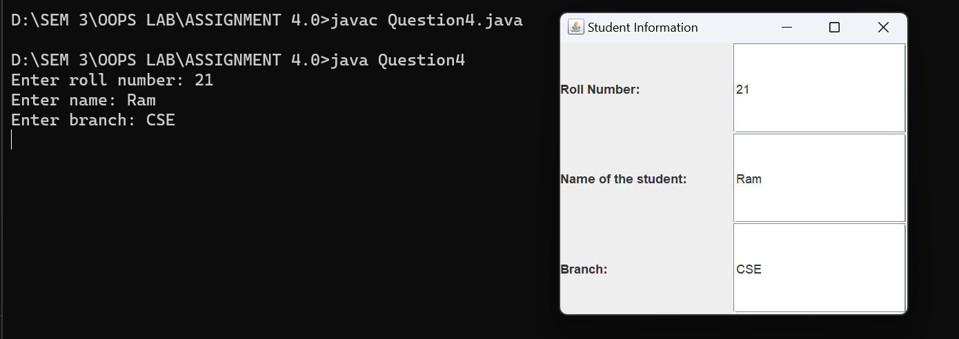

5 Write a calculator application having display as shown in below image. (Use BorderLayout for MainFrame, GridLayout for upper panel and flow layout for Button Panel.

CODE:

OUTPUT:

6 Write a program to demonstrate different window event handling.

**CODE:**

import javax.swing.*;

import java.awt.*;

import java.awt.event.*;

public class Question6 extends Frame implements WindowListener {

Question6() {

addWindowListener(this);

setSize (400, 400);

setLayout (null);

setVisible (true);

}

public static void main(String[] args) {

new Question6();

}

public void windowActivated (WindowEvent arg0) {

System.out.println("activated");

}

public void windowClosed (WindowEvent arg0) {

System.out.println("closed");

}

public void windowClosing (WindowEvent arg0) {

System.out.println("closing");

dispose();

}

public void windowDeactivated (WindowEvent arg0) {

System.out.println("deactivated");

}

public void windowDeiconified (WindowEvent arg0) {

System.out.println("deiconified");

}

public void windowIconified(WindowEvent arg0) {

System.out.println("iconified");

}

public void windowOpened(WindowEvent arg0) {

System.out.println("opened");

}

}

**OUTPUT:**

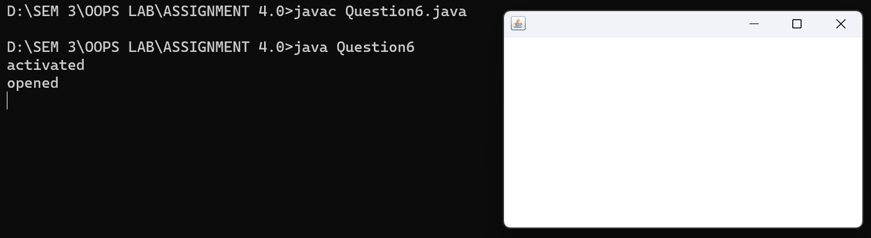

activated

opened

deactivated

activated

deactivated

activated

deactivated

activated

closing

deactivated

closed

7 Write a program to demonstrate mouse events handling.

**CODE:**

import java.awt.*;

import java.awt.event.*;

import javax.swing.*;

public class Question7 extends JFrame implements MouseListener{

Label l;

Question7(){

addMouseListener(this);

setDefaultCloseOperation(EXIT_ON_CLOSE);

l=new Label();

l.setBounds(20,50,100,20);

add(l);

setSize(300,300);

setLayout(null);

setVisible(true);

}

public static void main(String[] args) {

new Question7();

}

public void mouseClicked(MouseEvent e) {

l.setText("Mouse Clicked");

System.out.println("Mouse clicked");

}

public void mouseEntered(MouseEvent e) {

l.setText("Mouse Entered");

System.out.println("Mouse entered");

}

public void mouseExited(MouseEvent e) {

l.setText("Mouse Exited");

System.out.println("Mouse exited");

}

public void mousePressed(MouseEvent e) {

l.setText("Mouse Pressed");

System.out.println("Mouse pressed");

}

public void mouseReleased(MouseEvent e) {

l.setText("Mouse Released");

System.out.println("Mouse released");

}

}

**OUTPUT:**

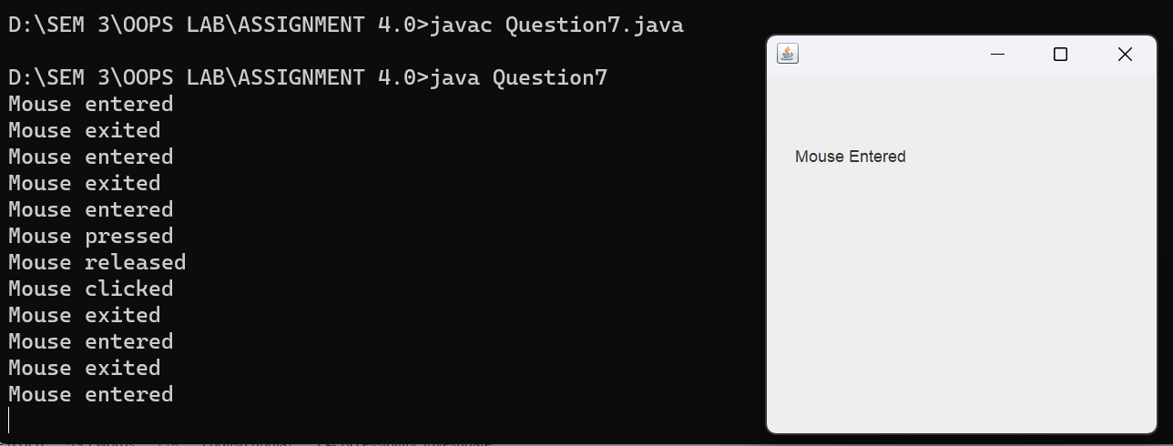

Mouse entered

Mouse exited

Mouse entered

Mouse exited

Mouse entered

Mouse pressed

Mouse released

Mouse clicked

Mouse exited

Mouse entered

Mouse exited

Mouse entered

Mouse exited

8 Write a program to demonstrate keyboard event handling.

**CODE:**

import javax.swing.*;

import java.awt.*;

import java.awt.event.*;

class Question8 implements KeyListener, ActionListener {

static JFrame frame;

static JTextField input, output;

public static void main(String[] args) {

frame = new JFrame("Question 8");

frame.setSize(500, 500);

frame.setLayout(null);

output = new JTextField();

output.setBounds(0, 0, 500, 50);

frame.add(output);

input = new JTextField();

input.setBounds(0, 400, 500, 50);

frame.add(input);

JButton exit = new JButton("Exit");

exit.setBounds(220, 200, 60, 30);

frame.add(exit);

Question8 obj = new Question8();

input.addKeyListener(obj);

exit.addActionListener(obj);

frame.setVisible(true);

}

public void actionPerformed(ActionEvent ae) {

frame.dispose();

}

public void keyReleased(KeyEvent e) {

output.setText("");

output.setText("Key Released : "+e.getKeyCode());

if(Character.isLetter(e.getKeyChar()))

keyTyped(e);

if(Character.isDigit(e.getKeyChar()))

keyTyped(e);

}

public void keyPressed(KeyEvent e) {

output.setText("");

output.setText("Key Pressed : "+e.getKeyCode());

if(Character.isLetter(e.getKeyChar()))

keyTyped(e);

if(Character.isDigit(e.getKeyChar()))

keyTyped(e);

}

public void keyTyped(KeyEvent e) {

output.setText("");

output.setText("Key Typed : "+e.getKeyChar());

}

}

**OUTPUT:**

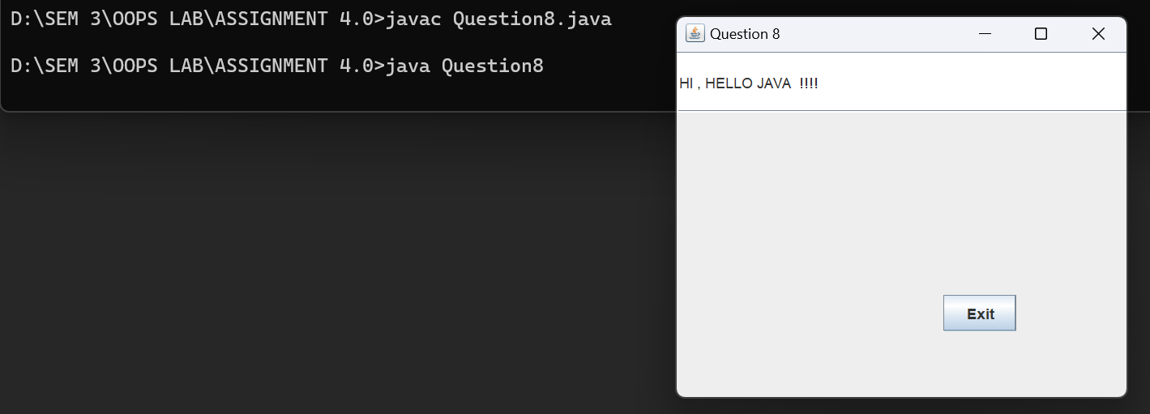

9 Write a program to demonstrate CardLayout (create 3 cards and first card uses BoxLayOut to arrange 3 buttons.)

CODE:

OUTPUT:

10 Draw an Oval filled with Random Color in middle of the frame and change its color (any random color) after every one second.

CODE:

OUTPUT:

11 Write a program to display inputDialog Box on clicking MenuItem – dialog.Than display confirmation dialog box to “asking do you want to exit from application?”.If yes Exit operation.If no than messageDialog displaying “Happy to see u here”.

CODE:

OUTPUT: